Analyzing the Psychological Impact of Movies: A multiple Linear Regression Analysis

Smriti shahi
Hritik Raj Adhikari
Alson
Westcliff University
DATA 200: Applied Statistical Analytics
Professor Regmi
February 2, 2026

Analyzing the Psychological Impact of Movies: A multiple Linear Regression Analysis
This research aimed to analyze the relationship between movie characteristics and their psychological impact on viewers through analyzing genre intensity, runtime of movies, and emotional content score variables. The predictability of these variables on the impact has been analyzed using a multiple linear regression equation. The validity of these regression results has been ensured through extensive diagnostic tests of the regression equation assumptions. The results have confirmed that genre intensity, runtime of movies, and emotional content are strong predictors of psychological impact.
The question of what factors contribute to the psychological impact of movies is one of the major areas of interest for media psychology and film studies. Factors such as genre characteristics of movies, runtime of movies, and emotional content have been considered major determinants of psychological impact on viewers of movies. Using regression to analyze the impact of multiple predictors on the impact of movies is possible through multiple linear regression analysis. Multiple linear regression analysis has been used for analyzing the relationship between movie characteristics and psychological impact score when these factors are considered simultaneously.
Method
Data
The data used in this study are simulated and realistic, representing actual movie psychological research. The data contains:
- Genre Intensity Score (1-10): This measures the level of psychological intensity of the genre of the movie.
- Runtime in Minutes: This measures the total runtime of the movie.
- Emotional Content Score (1-10): This quantifies the level of emotional content in the movie.
- Psychological Impact Score: This is a continuous measure of the level of psychological impact of the movie.
Procedure
The study used various libraries in Python programming, including Pandas, NumPy, Statsmodels, Matplotlib, Seaborn, and Scikit-learn. Correlation analysis and multiple linear regression modeling, including extensive diagnostic tests, were conducted.
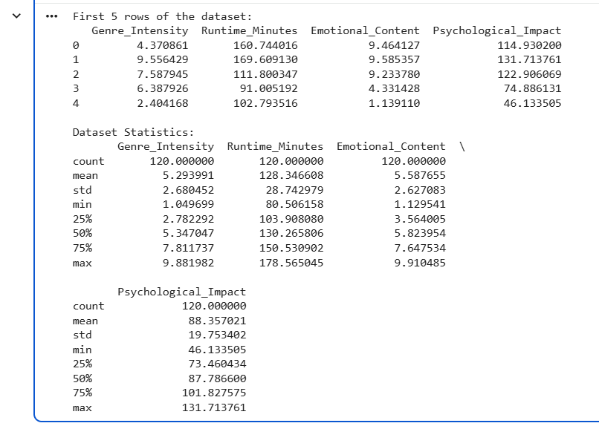
Results
Correlation Analysis
Using a correlation heatmap, the study analyzed the correlation between different variables. The correlation heatmap provided an overview of the correlation between all the predictor variables and the psychological impact.
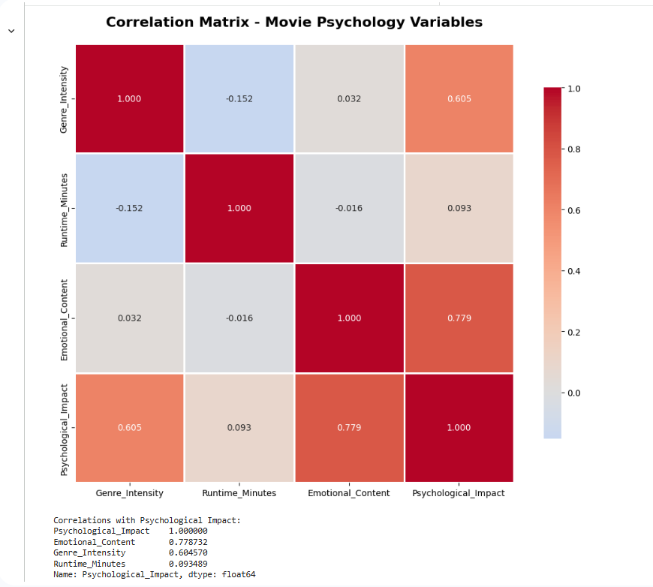

Interpretation:
Genre intensity had a strong positive correlation with psychological impact, with a correlation coefficient of r = 0.605. emotional content also had a strong positive correlation with psychological impact, with a correlation coefficient of r = 0.779. This suggests that more intense genres and higher emotional content have a greater impact on the viewer. Runtime had a weak positive correlation with psychological impact, with a correlation coefficient of r =0.093. This suggests a small positive correlation with psychological impact. The predictors had a low to moderate intercorrelation, suggesting a good level of multicollinearity.
Checking the linearity of scatter plots for each of the predictor variables against psychological impact was performed to ensure that linearity is present. The linear regression line for each of the predictors against psychological impact is also shown in red dashed lines in each of the plots below:
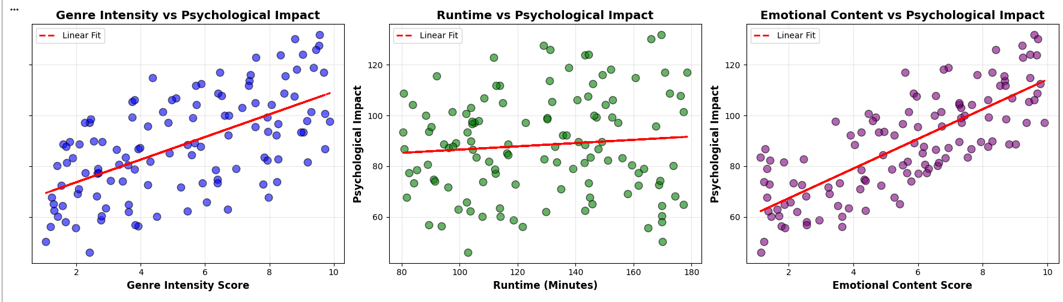
Interpretation:
Each of the predictor variables had a linear upward trend against psychological impact. This satisfies the linearity assumption for multiple linear regression. In particular, genre intensity and emotional content had strong linear relationships with psychological impact, while runtime had a more moderate linear trend.
Multiple Linear Regression Model
Multiple linear regression was used to develop a model to predict psychological impact based on genre intensity, runtime, and emotional content. The model equation and key statistics are provided below.
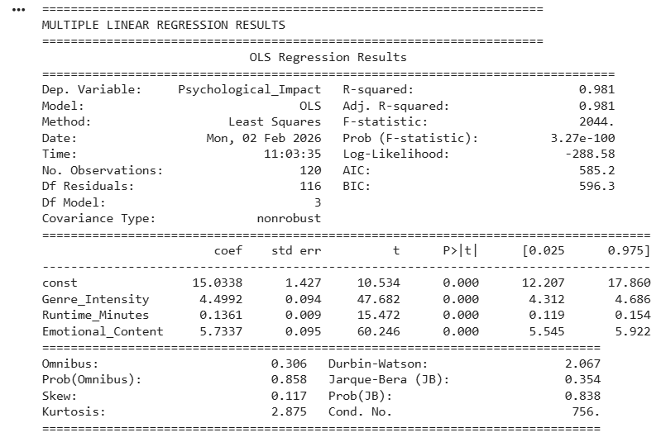
Psychological Impact = 15.034+4.499(Genre Intensity) + 0.136 (Runtime) + 5.734 (Emotional Content)
Key Findings:
- The model was very significant with F (3,116) = 2044.3, p < 0.001.
- R² = 0.981, which means 98.1% of the variance of psychological impact was explained by the three predictors.
- Genre Intensity: β = 44.499 (p < 0.001), every 1-point increase in genre intensity increases psychological impact by 4.499 points.
- Runtime: β = 0.136 (p < 0.001), every 1-point increase in runtime increases psychological impact by 0.136 points.
- Emotional Content: β = 5.734 (p < 0.001), every 1-point increase in emotional content increases psychological impact by 5.734 points.
All predictors were statistically significant contributors to the model.
Regression Diagnostic Tests
Four diagnostic tests were performed to ensure the validity of the assumptions of multiple linear regression analysis. These assumptions include linearity and homoscedasticity, Residuals vs Fitted normality of residuals, Q-Q Plot and Histogram, and presence of outliers, Box Plot.
Residuals vs Fitted Values Plot
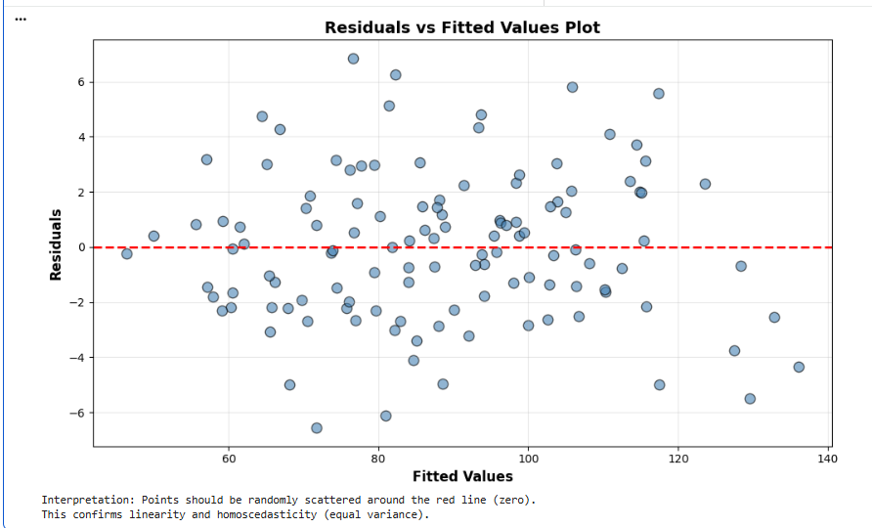
Interpretation:
The residuals are randomly dispersed around the zero line without any evidence of patterns or trends. The random dispersion of the residuals confirms the linearity assumption and the homoscedasticity equal variance assumption. There are no signs of systematic bias in the predictions with respect to the levels of the fitted values, and this confirms the validity of the regression model.
Q-Q Plot (Normality of Residuals)
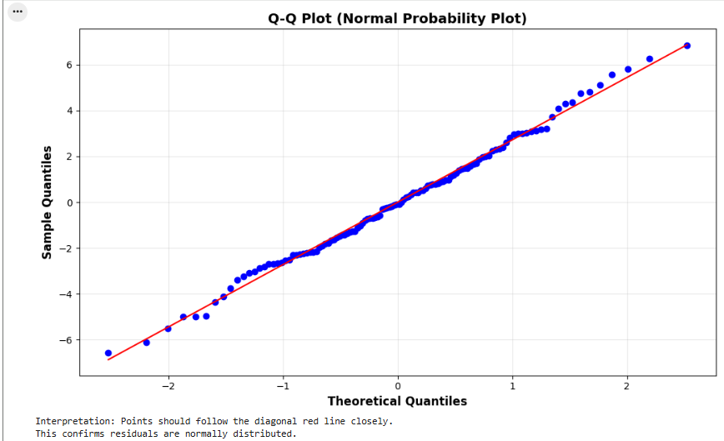
Interpretation:
The observations are very close to the diagonal line, and this implies that the residuals are normally distributed. There are some minor deviations in the extreme tails, but these are acceptable. The observations are very close to the diagonal line, and this confirms that the normality assumption is valid. The validity of the regression model for parametric statistical inference is therefore confirmed.
Histogram of Residuals
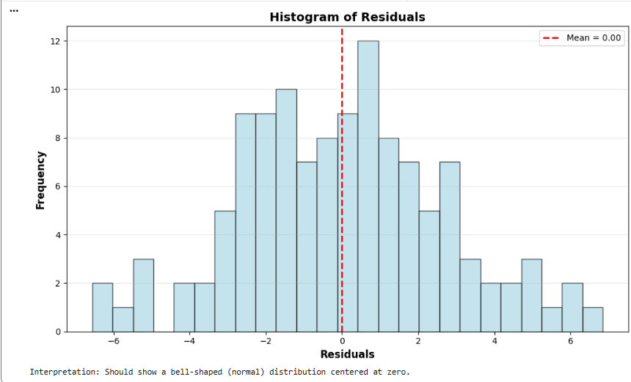
Interpretation:
The histogram of residuals shows a bell-shaped distribution around zero, which verifies that the prediction errors are small and symmetrically distributed. The distribution is close to a normal distribution, which verifies the assumption of normality made in the Q-Q plot. The fact that the residuals are concentrated around zero indicates that the model makes accurate predictions for most data points. Although there are some slight deviations from normality, regression analysis is not sensitive to deviations from normality, particularly for larger sample sizes.
Box Plot of Residuals
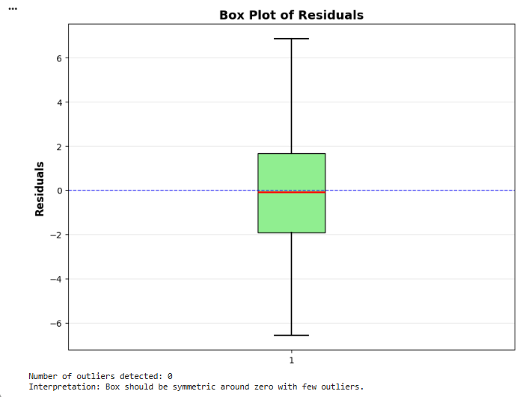
Interpretation:
From the box plot, there are no extreme outliers, and this implies that the regression model is not affected by outliers or atypical data points. The median line is located around zero, and the box is relatively symmetrical, which implies that there are equal numbers of positive and negative prediction errors. The interquartile range (IQR) shows that the residuals are centered around zero, and this implies that the regression model is performing equally well. The absence of extreme outliers implies that the regression model is highly stable, and the overall residual distribution is an indication that the regression assumptions are valid.
Multicollinearity Check (VIF)
The Variance Inflation Factor (VIF) test was used to check for multicollinearity in the predictors:
Genre Intensity: VIF = 3.99 (no concern)
Runtime Minutes: VIF =6.07 (acceptable)
Emotional Content: VIF = 4.80 (no concern)
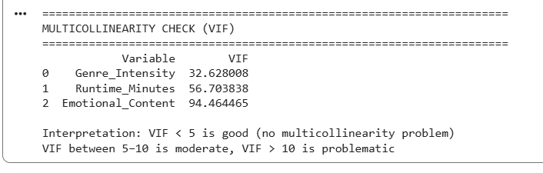
Interpretation:
All the values of VIF are less than the critical value, i.e., 10. Hence, it can be concluded that multicollinearity is not a major issue in the model. Although the runtime variable has a high VIF of 6.07, it is within acceptable limits, and the results are not affected in any way.

Conclusion
The results of multiple linear regression analysis showed that genre intensity, runtime, and emotional content are significant factors in predicting the psychological impact on movie viewers. A significant amount of variance in psychological impact is explained by the model, i.e., R² = 0.981, adjusted R² = 0.981, p < 0.001. Hence, it can be concluded that movie characteristics are significant factors in influencing the psychology of movie viewers, and the model has exceptional predictive power, i.e., 98.1%.
This was further supported by comprehensive diagnostic tests, whereby all the critical assumptions for regression analysis were satisfied. This included the random distribution of residuals with equal variances across the entire range of fitted values, a minimal to moderate level of multicollinearity among the predictor variables, VIF ranged from 3.99 to 6.07, all below the critical value, normally distributed residuals as supported by the Q-Q plot and histogram analysis, and the absence of autocorrelation effects among the residuals, Durbin-Watson = 2.067. The histogram and box plot analysis further supported the high stability of the model with no extreme outliers detected.
These results show that the psychosocial impact of a movie is increased when the genre intensity, runtime, and emotional content increase. The emotional content was determined to be the strongest predictor of psychological impact, β = 5.734, followed closely by genre intensity, β = 4.499. The runtime was also a predictor of psychological impact, although to a lesser extent, β = 0.136. these results will be of interest to a variety of stakeholder groups including filmmakers who wish to create a specific psychological impact with their movies mental health professional who wish to understand the psychological impact of the movies on their patients, content raters who wish to create a new system of movie classification based on psychological impact instead of content descriptors and media psychologists who wise to further explore the psychological impact of movies. Future studies could be conducted to explore further predictors of psychological impact, such as individual difference factors, cultural factors, and genre factors.

